# Spring Data JPA – Hands‑on 1 Implementation Report

## Database Setup (MySQL 8.0 / Workbench)

Executed commands:

CREATE SCHEMA ormlearn;

CREATE TABLE country (

co_code VARCHAR(2) PRIMARY KEY,

co_name VARCHAR(50)

);

INSERT INTO country VALUES ('IN', 'India');

INSERT INTO country VALUES ('US', 'United States of America');

## Application Configuration

src/main/resources/application.properties contents:

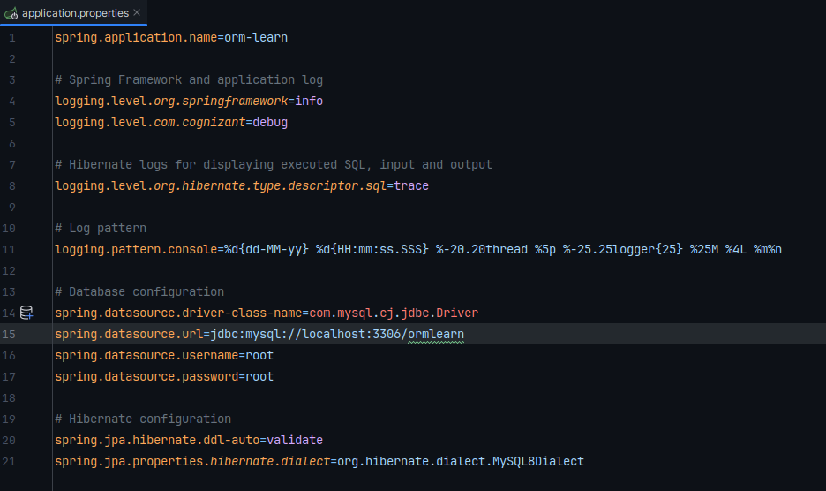

## JPA Entity – Country.java

## 

## Repository Interface – CountryRepository.java

## 

## Service Layer – CountryService.java

## 

## Main Application & Test Method –

## OrmLearnApplication.java

## 

## Build & Run

Executed build: **mvn clean package**

Ran the application successfully; country list retrieved and logged.

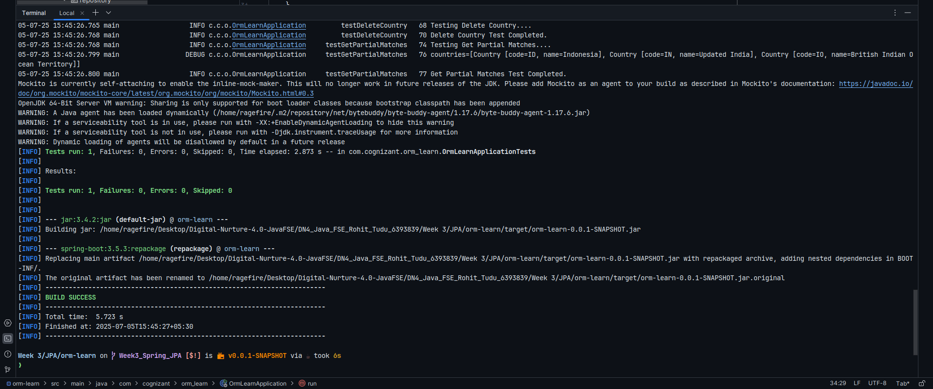

## Project Structure Overview

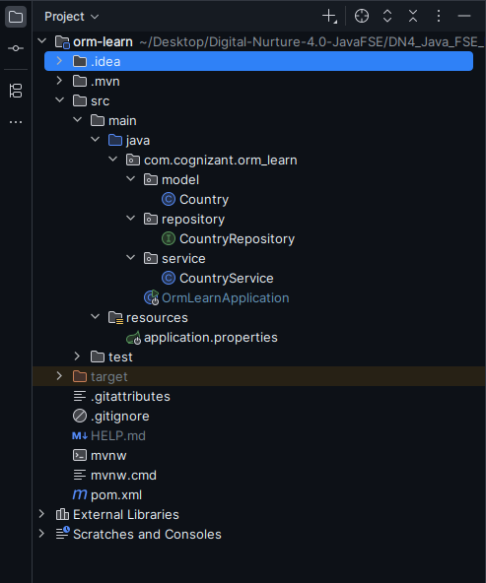

**src/main/java** – Main application, entity, repository, service

**src/main/resources** – Configuration filessrc/test/java – Test classes (context-load placeholder)

**pom.xml** – Maven build and dependencies

## Annotations & Configuration

| **Component** | **Annotation / Config** |
| --- | --- |
| Application | @SpringBootApplication |
| Entity | @Entity, @Table, @Id, @Column |
| Repository | @Repository extending JpaRepository |
| Service | @Service, @Transactional on service method |